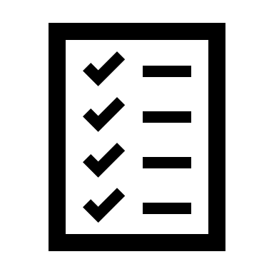
Checklist for finalizing your paper or thesis

Before your final check
Finish content changes
Proofread
Check punctuation
Remove extra spaces
Check citations and bibliography
Check hyphenation (if necessary)

During your final check
Look over your cover page
Add your abstract (if necessary)
Add and sign your signed declaration (if necessary)
Check the layout (line spacing, font size, margins, etc.)
Update the table of contents (if using)
Update other tables and indexes (if using)
Save in the correct format and print if required to do so

After your final check
Add additional materials (if necessary)
Hand in your work
Celebrate!

Presented by

